Transitional English 8/9 Block 1-2
MYP Language and Literature (Yrs 3/4)
Course Outline 2018-19

Teacher: Christy Coulthard
Email: ccoulthard@wvschools.ca
Room: C207

Introduction:
The Language and Literature curriculum provides students with opportunities to experience the power of language by exploring a variety of texts and the full range of contexts and purposes associated with the use of language. The development of literacy is a key focus of this curriculum. The rapid expansion in the use of technology and media has expanded the concept of what it is to be literate. Literacy today involves being able to understand and process oral, written, electronic, and multi-media forms of communication.

During this course we will work to develop your skills and confidence using English. Throughout the course every effort will be made to show how the power of language connects to other areas of study.

You will be encouraged to communicate your ideas and consider the thoughts and opinions of others. You will also work to develop yourself as communicating, caring, inquiring, risk taking, knowledgeable, reflective, open-minded, principled, balanced, and thinking individual.

Aims and Objectives:

This course meets the Learning Standards set out by the BC Ministry of Education and the MYP aims and objectives as described by the International Baccalaureate Organization. For a more detailed description of the Ministry of Education’s requirements please refer to:
https://curriculum.gov.bc.ca/curriculum/english-language-arts/8
https://curriculum.gov.bc.ca/curriculum/english-language-arts/9

The aims of MYP language and literature are to encourage and enable students to:
• use language as a vehicle for thought, creativity, reflection, learning, self-expression, analysis and social
interaction
• develop the skills involved in listening, speaking, reading, writing, viewing and presenting in a variety of contexts
• develop critical, creative and personal approaches to studying and analyzing literary and non-literary texts
• engage with text from different historical periods and a variety of cultures
• explore and analyze aspects of personal, host and other cultures through literary and non-literary texts
• explore language through a variety of media and modes
• develop a lifelong interest in reading and apply linguistic and literary concepts and skills in a variety of authentic
contexts.

The objectives of this course are:
A Analyzing
In order to reach the aims of language and literature, students should be able to:
- analyze the content, context, language, structure, technique and style of text(s) and the relationship among
texts
ii. analyze the effects of the creator’s choices on an audience
iii. justify opinions and ideas, using examples, explanations and terminology
iv. evaluate similarities and differences by connecting features across and within genres and texts.

B Organizing
Students should be able to:
i. employ organizational structures that serve the context and intention
ii. organize opinions and ideas in a sustained, coherent and logical manner
iii. use referencing and formatting tools to create a presentation style suitable to the context and intention.

C Producing Text
Students should be able to:
- produce texts that demonstrate insight, imagination and sensitivity while exploring and reflecting critically on
new perspectives and ideas arising from personal engagement with the creative process
- make stylistic choices in terms of linguistic, literary and visual devices, demonstrating awareness of impact on an
audience
- select relevant details and examples to develop ideas.

D Using language
Students should be able to:
i. use appropriate and varied vocabulary, sentence structures and forms of expression
ii. write and speak in a register and style that serve the context and intention
iii. use correct grammar, syntax and punctuation spell
iv. spell (alphabetic languages), write (character languages) and pronounce with accuracy
v. use appropriate non-verbal communication techniques.

Approaches to Learning:
Throughout this course, we will be using various approaches to learning.

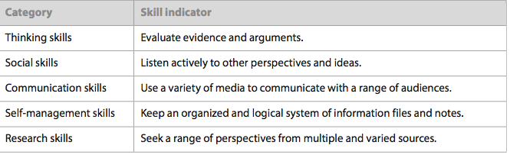

Concept Based Learning through Global Contexts:

MYP inquiry recognizes the integrity of subject disciplines, but learning is richer and deeper when conceptually driven. Building a deep understanding requires meaningful reflection. MYP uses a fluid, differentiated model to encourage learning and uses the Global Contexts as a context to drive inquiry.

The global contexts and key/related concepts will be addressed in Language and Literature by exploring the following:

Unit Title | Global Context | Key Concepts | Related Concepts | Statements of Inquiry  Unit Question
Influences in Life  Short Stories  Sept/Oct | Identities and Relationships | Connections | Character,  Setting, Point of  View, Theme,  Self Expression | Various factors influence your actions  What Influences How You Act?
True Self  Short Stories /  Non-Fiction  Nov/Dec | Personal and  Cultural  Expression | Perspective | Genre, Context, Setting, Point Point of View, Theme | Find out who you really are  Do We Find or Create Our True Selves?
Challenges  Novel Study  Jan/Feb | Fairness and Development | Perspective | Genre, character, theme, setting, point of view, purpose | Your background shapes who you are  How do challenges in life help us grow?
Give and Take  Non-Fiction & Multimedia  March/April | Globalization and Sustainability | Connections | Audience Imperatives, Context, Self-expression | Stand up for what you believe  How can you make a difference?
Understanding What’s Important  Poetry & Drama  May/June | Identities and Relationships | Creativity | Self-expression, genre, style, purpose, theme | Reflect on your life and think about the  future  What’s important to you?

Texts/Resources
- Textbook: Edge - Level A (Hampton Brown/National Geographic)
- Seedfolks and/or The Breadwinner and/or Parvana’s Journey and/or Necessary Roughness
- Various multi-media (short stories, folk tales, non-fiction, film)

Required Materials:
- Notebook (for journals and notes)
- Binder and lined paper
- Pencil, pen, highlighter
- Personal device (laptop, tablet)

Methods of assessment:
Possible forms of assessment this year may include:
Formative  (monitor student progress) | Summative  (evaluate achievement of learning outcomes)
Homework | Unit Tests
Warm up questions | Writing Portfolios
Checkpoints (oral, written, quizzes) | Projects and Presentations
Self, peer, and teacher reflection and evaluation providing ongoing Feedback

Formative Assessment: Students will have frequent quizzes and complete rough drafts of assignments to demonstrate what they understand and what they still need help with. Students will also have class work and homework that they will correct with classmates and the teacher. Students will be encouraged to discuss their thinking about the various problems and topics covered in class.
- Used to check students’ progress
- The information gained guides the next steps in instruction and helps consider the additional learning opportunities needed to ensure success

Summative Assessment: At the end of each unit students will write tests. Students will also partake in individual and group projects and do self-assessments of their learning. Students will be required to demonstrate their knowledge, their understanding, applications of skills and concepts in a manner that is clear and organized in all the above mentioned forms of summative assessment.

• Summative assessments provide information about the attainment of knowledge
• Results translate to an overall level of achievement.
• The goal is to evaluate student learning at the end of an instructional unit by comparing it to the
IBO standards

All grading will be based on MYP assessment rubrics and BC Prescribed Learning Outcomes.

Evaluation Guide:

Criterion A: Analyzing
Criterion B: Organizing
Criterion C: Producing Text
Criterion D: Using Language

In English, student’s work is assessed on an 8 point scale. This is not a score “out of 8”, therefore a result
of 4/8 does not equate to 50% but is closer to a 70%.
MYP Grade | Approximate Letter Grade
8 | A+ | Exceeds expectations
7 | A | Excellent work
6 | A-/B+ | Very good work
5 | B | Good work
4 | B-/C+ | Decent effort, Satisfactory work
3 | C | Satisfactory work
2 | C/C- | Meets minimal standards, all work is being completed
1 | C-/I | Insufficient effort, but work is usually completed
0 | I | Work is not being completed/No effort
All marks are cumulative. Students must show continuous growth from September through June. Though a student may start with a 1 or 2 does not mean they cannot achieve a higher MYP level by the end of the year.
The final mark is not an average of all three terms. Current level of progress or trending results are used to report level of achievement. Therefore, always try your best and don’t give up!

IB Criterion total /32 | IB grade | BC % Conversion
1-5 | 1 | 0-44
6-9 | 2 | 45-55
10-14 | 3 | 56-69
15-18 | 4 | 70-77
19-23 | 5 | 78-86
24-27 | 6 | 87-95
28-32 | 7 | 96-100

For the term 3 report card, each student will receive a FINAL IB grade (1-7) for each subject. That is determined by adding the most recent and consistent achievement level on each of the 4 criteria together and then using the chart to the right to make the conversion. On the grade 9 and 10 FINAL report cards – a percent and corresponding letter grade will also be awarded. Please see the chart to the right for how that conversion is made.

The descriptors for each IB Final Grade are explained below from 1 (lowest) to 7 (highest). These descriptors reflect the objectives of the eight subject areas. All of the IB MYP subject criteria, along with the Rockridge Assessment Policy, can be found on the MYP page of our school website.

IB Final Grade | Descriptor
1 | Produces work of very limited quality. Conveys many significant misunderstandings or lacks understanding of most concepts and contexts. Very rarely demonstrates critical or creative thinking. Vary rarely applies knowledge or skills.
2 | Produces work of limited quality. Expresses misunderstandings or significant gaps in understanding for many concepts and contexts. Infrequently demonstrates critical or creative thinking. Infrequently applies knowledge and skills.
3 | Produces work of an acceptable quality. Communicates basic understanding of many concepts and contexts, with occasionally significant misunderstandings or gaps. Begins to demonstrate some basic critical and creative thinking. Occasionally applies knowledge and skills, requiring support even in familiar classroom situations.
4 | Produces good-quality work. Communicates basic understanding of most concepts and contexts with few misunderstandings and minor gaps. Often demonstrates basic critical and creative thinking. Applies knowledge and skills in familiar classroom situations, but requires support in unfamiliar situations.
5 | Produces generally high-quality work. Communicates secure understanding of concepts and contexts. Demonstrates critical and creative thinking, sometimes with sophistication. Applies knowledge and skills in familiar classroom and real-world situations and, with support, some unfamiliar real-world situations.
6 | Produces high-quality, occasionally innovative work. Communicates extensive understanding of concepts and contexts. Demonstrates critical and creative thinking, frequently with sophistication. Applies knowledge and skills in familiar and unfamiliar classroom and real-world situations, often with independence.
7 | Produces high-quality, frequently innovative work. Communicates comprehensive, nuanced understanding of concepts and contexts. Consistently demonstrates sophisticated critical and creative thinking. Frequently applies knowledge and skills with independence and expertise in a variety of complex classroom and real-world situations.

Policies and Procedures:
Follow the Rockridge Secondary School Code of Conduct as defined in the school agenda. Respectful behaviour is expected at all times regarding fellow students, staff, materials and leaning environment.

Attendance:
Attendance and punctuality are mandatory. There will be no opportunity to make up work for unexcused lateness or absences. In the case of an excused absence or lateness, it is the responsibility of the student to make up the missed work promptly. The same due dates of assignments and tests apply to all students, even those with absences

Late Assignments:
If a student fails to hand in an assignment on the due date he/she may be required to hand in an alternate assignment.

Test Dates:
Students will be expected to write major unit tests and in-class writing assignments on the set date. Since these dates are established well ahead of time, it is the student’s responsibility to inform the teacher of his/her absence prior to the date or bring a parent and/or doctor’s note for illness. Excused missed tests will be written on an established date set by the teacher

Extra Help: You may come see me in C207 or email me to set up an appointment ccoulthard@wvschools.ca

Homework: Small assignments will be listed on the whiteboard in the classroom. Tests, presentations, large assignments and projects will be posted on google classroom.

Website: Website: christycoulthard.weebly.com. All resources and assignments will be posted on google classroom. Please ask Mrs.Coulthard for the classroom code.

Cell Phones/Laptops: Cell phones should be in your backpack or locker. Please bring your laptop to class every day.

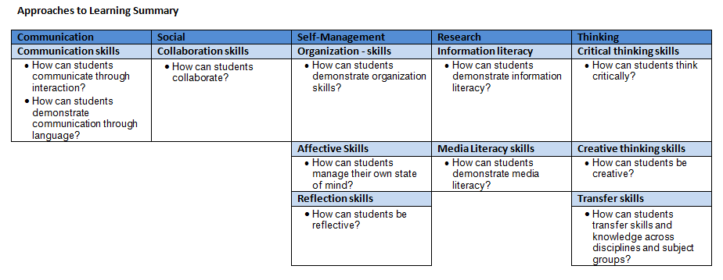
Work Habits: Work habits will be evaluated in the following manner

Descriptors:
Symbol | Term | Descriptor
E | Expert | The student shows others how to use these skills and self-assesses his/her usage
P | Practitioner | The student often demonstrates these skills effectively without being asked
L | Learner | The student uses these skills if they are demonstrated or specifically asked
N | Novice | The student rarely uses these skills
N/A | Not Assessed | Not assessed during this reporting period

If work is late more than 2 times per term you will receive an “N” for Self-Management.

Academic Integrity:

Keep this outline at the front of your binder. Cut off the section below and hand in to _________ by: _____________

Plagiarism is a serious offence and will result in no credit on the given assignment/project. You will NOT be permitted to resubmit the assignment a second time. If it is suspected that plagiarism has taken place for an assignment or project, it will be investigated and an administrator will be notified. May be recorded on school and/ or academic file.

I understand what plagiarism is and the consequences, and promise not to plagiarize. I promise to complete all assignment to the best of MY abilities (I will not get a tutor/friend/family member to assist in the completion of projects*):

Student initial here: __________________ Parent/Guardian initial here: __________________

*Tutors/Friends/Family Member may assist with studying, review and textbook/workbook homework but you must complete summative assignment on your own (I need to evaluate YOUR abilities, not someone else’s!)

Your academic integrity is vital to your overall success. Cutting corners will not do you any favors. Even if you are not officially “caught” cheating, it is often clear to a teacher who is not doing the work themselves.

If your project assessments are too different than those on your test/quiz assessments, you may not be credited for the project at all. Always do your work to the best of YOUR abilities.

Please read the above outline entirely and sign below. Note my e-mail address located on the front (top right) of this outline. Please e-mail me with any questions, concerns or to inform me of an absence ahead time.

I, _____________________________________________ (student’s full name) have read and understand the above course expectations.

Signature of student: __________________________________________________ Date: _____________________

Student e-mail address: ____________________________________________________________________

